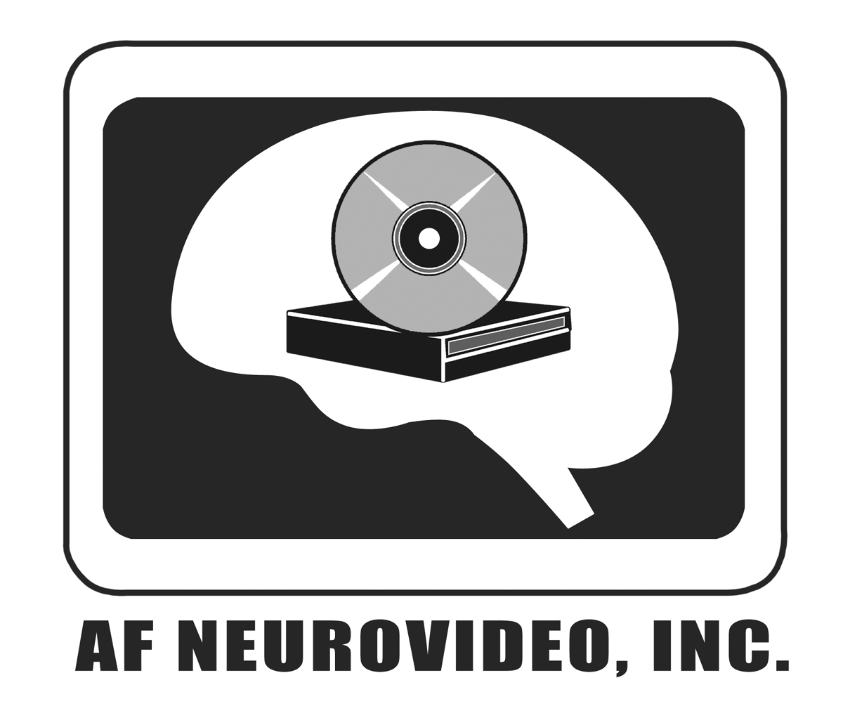
AF-Neurovideo, Inc.
Dedicated to the Education of Neurosurgeons of the Future
Lori Radcliffe, Business Manager

4030 Wake Forest Road, Suite 115 Phone: 919-239-0264

Raleigh, NC 27609, USA Fax: 919-239-0266
e-mail: afneurovideo@carolinaneuroscience.com
www.skullbaseneurosurgery.com

Returns and Exchanges
AF-NeuroVideo Inc. makes every effort to accurately represent the books, DVDs, videos and downloads being sold on these pages. Unopened books, videos and DVDs may be returned for credit, exchange, or refund.

Downloads are non refundable.

Shipping charges are non refundable.

You must notify us by email at afneurovideo@carolinaneuroscience.com within 7 days of signing for receipt of goods. You will receive from us a return authorization code and you must ship the return merchandise, prepaid, to us within 5 days of receiving the return code.
Returned items must be unopened and in the condition received: unfortunately we cannot offer refunds on books, DVDs or videos that have been opened, used, or in any way altered.
You are responsible for return freight charges unless the error was ours, and we recommend shipping UPS, DHL, FedEx or US Postal insured.

Refunds will be in the form of payment made. Refunds will be made within 5-7 days of receipt of goods.

